Tenda W6-S – How to check the status information of AP?

Q: How can I tell if my AP is connected to the internet? How can I view my settings about the AP?

- Click on “Status”, double click “System Status” to check the connection information after you login the page.

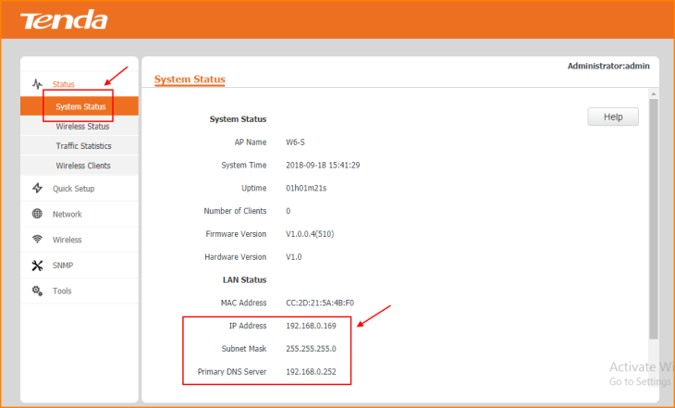

Note: If the “IP Address” could obtained properly which means the successful connection.

- Click on “Wireless Status” to see the RF Status.
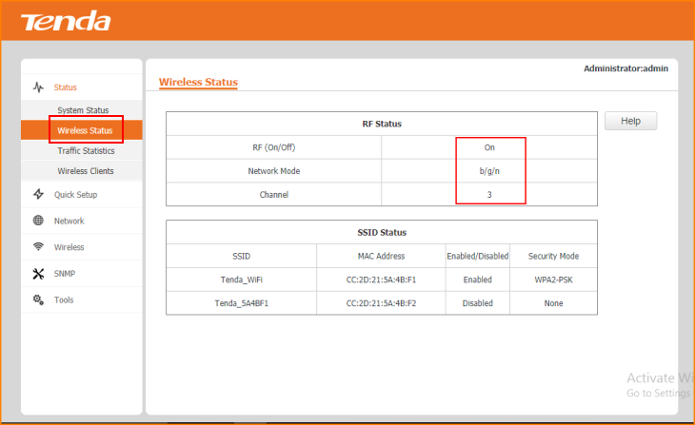

Note: You can change the parameters from the “Wireless” option.

- Click on “Traffic Statistics” of connected Access Point.
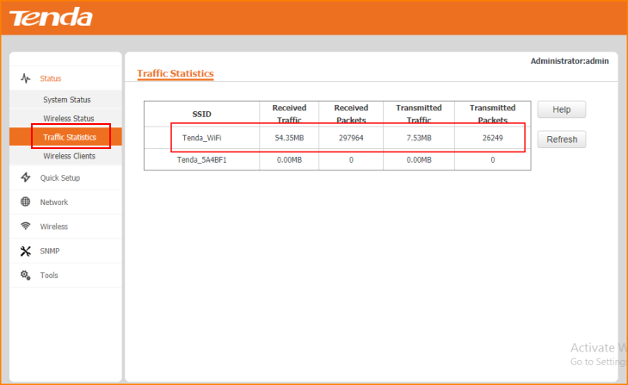

- Click on “Wireless Clients”.

